Planning Statement of Purpose for Creative Fit

Step 1: Analyze the question
Please upload a brief (1,000 words maximum) personal statement that:
- Explains your interest in this area
- Describes any relevant research experience - for example, as part of a previous degree
- Lists any academic work you have published or which is awaiting publication

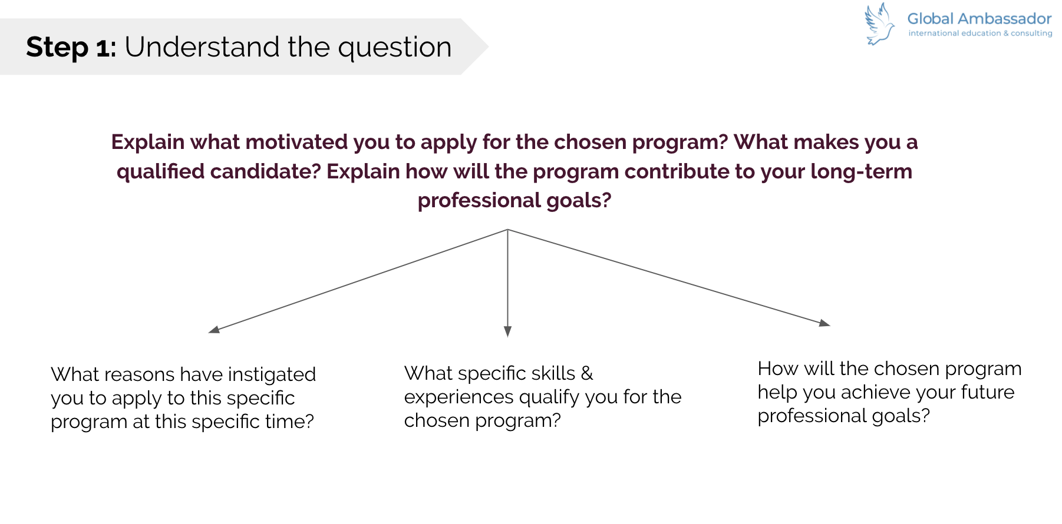Task: Analyze the question above and write down these questions:
- What is the type of question here?
- What sub-questions are you supposed to answer?
1.
2.
3.

Step 2: Brainstorm the content

Task 1: Complete the table below for the Creative Fit Candidate.
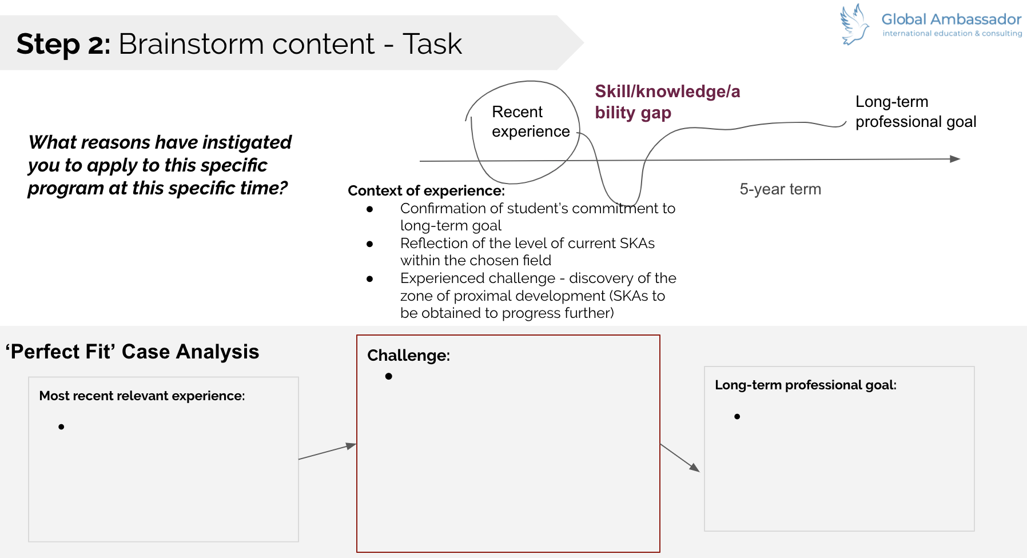

Most recent relevant experience. Name the experience. What relevant skills and experience has she demonstrated | Challenge. What specific challenge did she face? What did it tell her about SKEs to be acquired? | Long-term professional goal

Task 1: Based on the chosen program MSc FT Entrepreneurship and Innovation, complete the analysis of the program and group desired skills and experiences into meaningful categories. (Complete 2nd line)
 | Group 1:  Skills & Experiences that the program expects | Group 2:  Skills & Experiences that the program expects | Group 3:  Skills & Experiences that the program expects
Based on program’s requirement
Evidence from student’s background
(give 2-3 examples per group)

Task 2: For each of the category, write down examples of experiences of ‘Creative Fit’ candidate and skills that illustrate compatibility with each of the Groups’ expected skills and experiences (Complete 3rd line above).

Step 3: For each of the ‘to be acquired’ SKEs (Complete Challenge Column) revealed through the most recent relevant experience specify program’s features that would allow her to gain these SKEs.
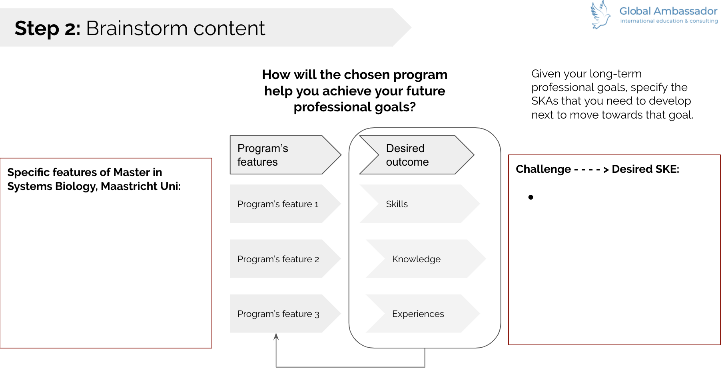

Program’s features | Desired SKEs

